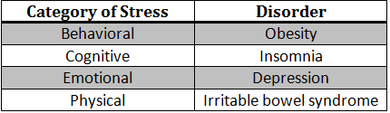
Slide 1
Title Slide with Name, Course, and Date
Slide 2 - Introduction
Topics to be covered in outline form
Slides 3-5
Choose one disorder from the table above. Briefly describe your chosen disorder. What are the symptoms of your chosen disorder? How does stress affect/cause/manifest/enhance this condition? How many people are affected by the disorder? Describe how your chosen disorder is associated with its main category of stress from the table (i.e., how is insomnia sometimes a cognitive condition?).
Slide 6
Describe how your chosen disorder overlaps with the other categories of stress listed from the table (i.e., obesity may be influenced by behavioral styles such as overeating in reaction to stress, but there may be emotional components as well).
Slides 7-8
Choose and describe one occupation at high risk for stress (firefighter, policeman, trauma nurse, service member, air traffic controller, etc). What are the main causes for your chosen occupation’s stress? How does this stress affect their ability to perform? (Be sure to incorporate aspects of physical, emotional, cognitive, and/or behavioral functions). Include an image representing your chosen occupation.
Slide 9 - Conclusion
Summarize your project findings.
Slide 10—References
APA Format

